Sample Sign

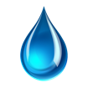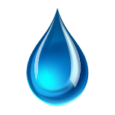
WATER TESTING IN PROGRESS
PLEASE DO NOT USE ANY WATER SOURCES – SINKS, FOUNTAINS, TOILETS, ETC.

